CSA 283: Exam One

Name: ______________________________________ Section: _____ _____

Please write legibly. Ask questions if something is unclear. Be concise in written answers.

Exam is printed on both sides!

You may use the Java 2 Platform Std. Ed. 6.0 documentation at http://java.sun.com/javase/6/docs/api/. You may not use any other documentation or notes unless you want to get a zero for the exam.

Some useful formulas:
d_{trans} = L/R d_{prop} = d/s

Questions:

- List the five protocol layers of the Internet in order from highest to lowest. (5 points)

_______________________,

_______________________,

_______________________,

_______________________,

_______________________,

- Bit torrent uses a “tit-for-tat” paradigm. Explain what is it and why is it important to overall system function. (no more than four sentences) (4 points)

- Give definitions for the following terms using one or two sentences. If the term is an acronym, also state what the letters in the acronym stand for and give a definition.
(15 points)

a. Elastic application:

b. Transmission delay:

c. Conditional Get:

d. Traffic Intensity:

d. FDM:

- Is the Internet a Datagram network? Explain why or why not using no more than two to three sentences. (4 points)
- Consider the following scenario:

You are designing a networked application. It is a peer to peer application in which peers exchange real-time sensor data. Each peer should receive as many sensor data samples as possible from all the other peers. However, is not necessary for each peer to have every single data sample. Peers will operate best if the data they do process is received with as little time delay as possible. Which transport layer protocol would you use to support this application? Why? (5 points)

- Consider the following scenario:

Host A opens a connection to host B. After a handshaking protocol is completed during which host B sends a public key to host A, host A sends data to host B which processes the data and stores it for later retrieval.

In the above scenario, which host is the client and which is the server?
(4 points)

Client: _______________

Server: _______________

- List three of the four reasons DNS uses a distributed database instead a centralized database. (6 points)

________________

________________

________________
- Consider the following scenario:

Assume a web browser opens a TCP connection to a web server in order to download a web page. The browser sends a request message over the connection requesting the base HTML-file object. The web server responds by sending a response message containing the file. The browser parses the html file and finds nine referenced objects. The browser serially sends a get message requesting each of the objects and receives them over the same connection from the web sever. After receiving all of the objects the browser closes the TCP connection. (14 points)

a. What type of HTTP connection is the browser using?

b. Assuming zero transmission time for all objects, how many RTTs will it take to download the HTML file and the nine referenced objects? (explain or show your reasoning)

c. What type of HTTP connection could the browser use to download the objects more quickly?

d. Approximately how many RTTs would be required to download the web page and the nine referenced objects when using this faster method? (explain or show your reasoning)

- What type of object does a java client application instantiate in order to open a reliable connection to a server? (2 points)
- Use the constants below to answer the following questions. Show work for partial credit. Indicate the units for each answer. Show times to five decimal places. Assume processing and queuing delays are negligible.

Bits being transmitted 40,000 bits
Packet Size 1000 bits
Link Bandwidth 40,000 bps
Link Lengths 10,000 Meters
Propagation Speed 2.8 x 10⁸ Mps

a. Calculate the propagation delay for a single link. (3 points)

b. Calculate the transmission delay for a single packet and a single router.
(3 points)

- Assuming there are six links connected by routers and that processing and queuing delays are negligible, calculate the time required for a single packet to travel from A to B at the end of the sixth link. (6 points)
A
B

- Again, assume there are six links connected by routers and that processing and queuing delays are negligible. For pipelined transmission, calculate the time needed for the entire file to reach B at the end of the sixth link. (8 points)

- Consider the following scenario:

A network application running on reds.mlb.com wants to transmit packets to redhwaks.muohio.edu. In the following, assume that all DNS servers (including the local name server) use caching and that all DNS caches initially contain bare minimal information. Queries to the local name server are handled recursively. Assume all other queries are handled iteratively. DNS server names are as follows:

TLD DNS server, edu: dns.tld.edu
TLD DNS server, com: dns.tld.com
Local DNS server, mlb: local.mlb.com
Local DNS server, muohio: local.muohio.edu
Authoritative DNS, muohio: dns.muohio.edu
Authoritative DNS, mlb: dns.mlb.com
Root DNS server: dns.root

- 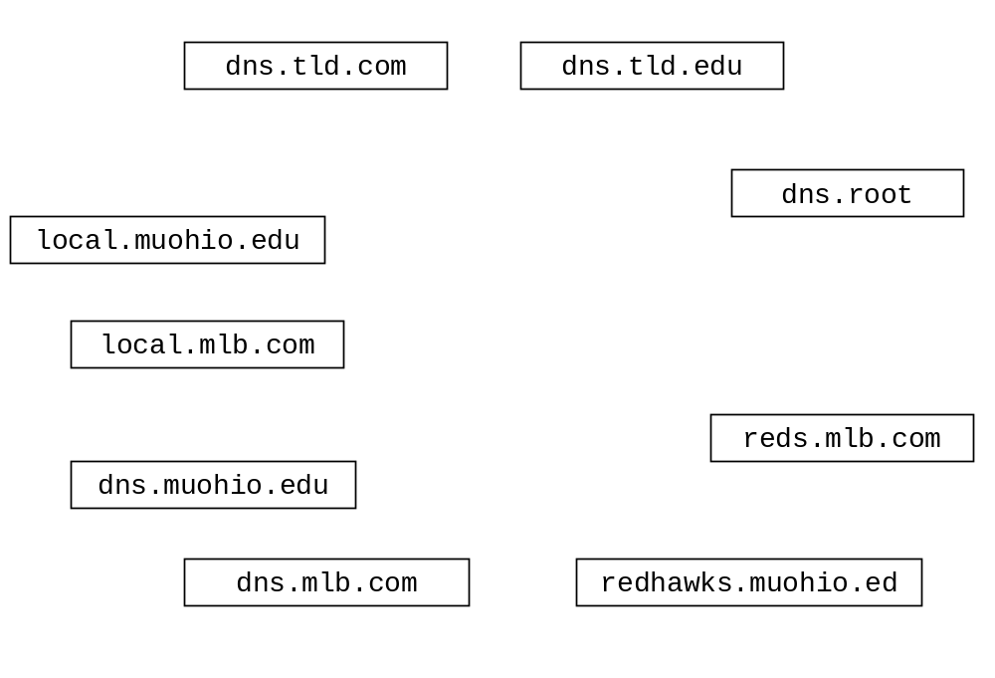Draw arrows labeled with numbers to indicate the order of queries and responses sent before frodo.nps.edu receives the IP address of sam.muohio.edu.
(16 points)

- After the sequence in part a. has occurred, suppose Phillies.mlb.com wants the IP address for redhawaks.muohio.edu. How would the sequence of events be different? What machines would be involved?(4 points)

- If a machine needed to send email to an address in the mlb.com domain, what type of resource record would contain the name to the mail server for that domain. (circle one)
(3 points)

Type A Type NS Type CNAME Type MX

- FTP and HTTP can both be used to download files from a remote machine. The two protocols are similar in many ways. Briefly describe a significant different in how they operate to accomplish this download task (no more than three sentences). (4 points)

- Complete the Client class on the next page. Do not worry about handling exceptions. Allow the main method to throw all exceptions to the OS. (26 points)
- Clients contact the Server using TCP and send one int followed by some number of floats or a single int equal to -1 followed by nothing.
- Assuming single -1 is not sent, the leading int indicates how many floats are being sent, the Server calculates the sum of the floats and sends the sum back to the client as a float.
- The connection between the client and server is kept open until the client wishes to close it.
- When a user of the client no longer wishes to send numbers, the client sends a -1and both the client and the server close the connection. The server will continue to run and process numbers from other clients. The client will terminate.
- The Server listens for clients on port number 31200. The server IP address is 134.53.130.254

import java.io.*;
import java.net.*;
import java.util.Scanner;

public class SumClient {

public static void main(String[] args) throws Exception
{
Scanner scan = new Scanner(System.in);
- The StringHashServer class, shown below, implements a server that will receive Strings from clients and send back the hash code for the String as an int. Complete the StringHashClient class so that it sends a string to a host running the StringHashServer server, receives back the hash code and prints it out to the console before closing. Use the getBytes method of the String class to get a byte array representation of a string. Close streams and sockets before the client exits. Assume the IP address of the machine running the server is 134.53.130.254 (26 points)

import java.io.*;
import java.net.*;

public class StringHashServer {

public static final int MAX_LENGTH = 1024;

public static void main(String[] args) throws IOException {

boolean processMoreStrings = true;
String line;
byte recArray[] = new byte[MAX_LENGTH];

ByteArrayOutputStream baos = new ByteArrayOutputStream();
DataOutputStream dos = new DataOutputStream(baos);

DatagramSocket serverSocket = new DatagramSocket(9876);

DatagramPacket packet =
new DatagramPacket(recArray, recArray.length);

while ( processMoreStrings ) {

serverSocket.receive(packet);

ByteArrayInputStream bais =
new ByteArrayInputStream(packet.getData());

byte lineBytes[] = new byte[packet.getLength()];

bais.read( lineBytes );

line = new String( lineBytes );

baos.reset();

dos.writeInt( line.hashCode() );

packet.setData( baos.toByteArray() );

serverSocket.send(packet);

packet.setData(recArray);

}
serverSocket.close();
} // end main
}
import java.io.*;
import java.net.*;
import java.util.Scanner;

public class StringHashClient {

public static void main(String[] args) throws Exception {

Scanner scan = new Scanner(System.in);

